Cell Phone Contract
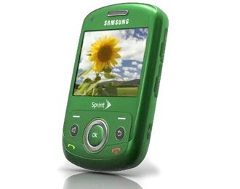
Agreement between _________ and _______________

DATE \@ "MMMM d, y" April 28, 2014

Partnership Agreement
to learn how to use a cell phone appropriately and God-girly

I know that having an cell phone is a privilege. I respect that the parents love me and want to keep me safe. The parents respect that I am becoming a young adult and want the privilege of having the use of using a cell phone. With that in mind, I agree to the following terms for six months. Terms to be evaluated and renewed November 1, 2013:
- I agree to pay 50% of the cost for service, which is $15 per month. I will pay dad on the first of each month in full. I understand lack of payment may mean suspension of service. Service plan includes the following:
  - 150 talk time
  - 500 messages
  - 50mb of data
- The cell phone must be turned in to the charging station each night. It is my responsibility to be sure it is being recharged.
- I agree that when I’m home, I’m home - I will put the phone in the kitchen drawer so my attention and focus can be with my family, not a phone.
- I agree that if I am unable to keep up with the responsibilities or being disrespectful at home, the use of the cell phone can be taken away from me.
- I will not use the cell phone to take pictures or video of nudity, violence or other unlawful activity.
- I will not use the cell phone to for malicious purposes. (bullying, etc.)
- I will not use the cell phone in the bedroom with the door closed when I’m alone.
- When I get home, I will not use the cell phone until the homework and responsibilities are done.
- I must agree to give the cell phone immediately to my parents whenever they ask for it. I must fully cooperate in showing them the contents of the apps, including contacts, pictures, videos, or anything else stored in the cell phone.
- I will abide by the school’s rules regarding use of the cell phone.
- Any abusive use of the cell phone will mean I will lose it for a period of time. Abuse includes sending or storing inappropriate content (nudity or partial nudity, drug or alcohol references, harassing or bullying messages, spreading rumors, sending or receiving pictures from strangers, etc.)
I agree to abide by the guidelines above. All terms subject to change. I understand that if I do not follow them, my cell phone usage privileges will be suspended.
I, ____________________, understand that the wonderful parents are generous enough to provide me with an amazing device, and therefore, I will respect them by abiding by the rules of usage above. I fully understand the consequences if I choose not to do so.

______________________________ Student Name
______________________________ Dad
______________________________ Mom

